**CSE3506 – ESSENTIALS OF DATA ANALYTICS**

**EXPT NO: 3**

**DATE:** 17/2/2021

**NAME:** R. Harini

**REG. NO.:** 18BCE1010

**REGRESSION AND FORECASTING ON WEATHER DATA**

**AIM**

Understand the following operations/functions on weather related dataset “weatherHistory2016.csv” and perform similar operations on another weather related dataset based on given instructions.

**MATLAB PROGRAM**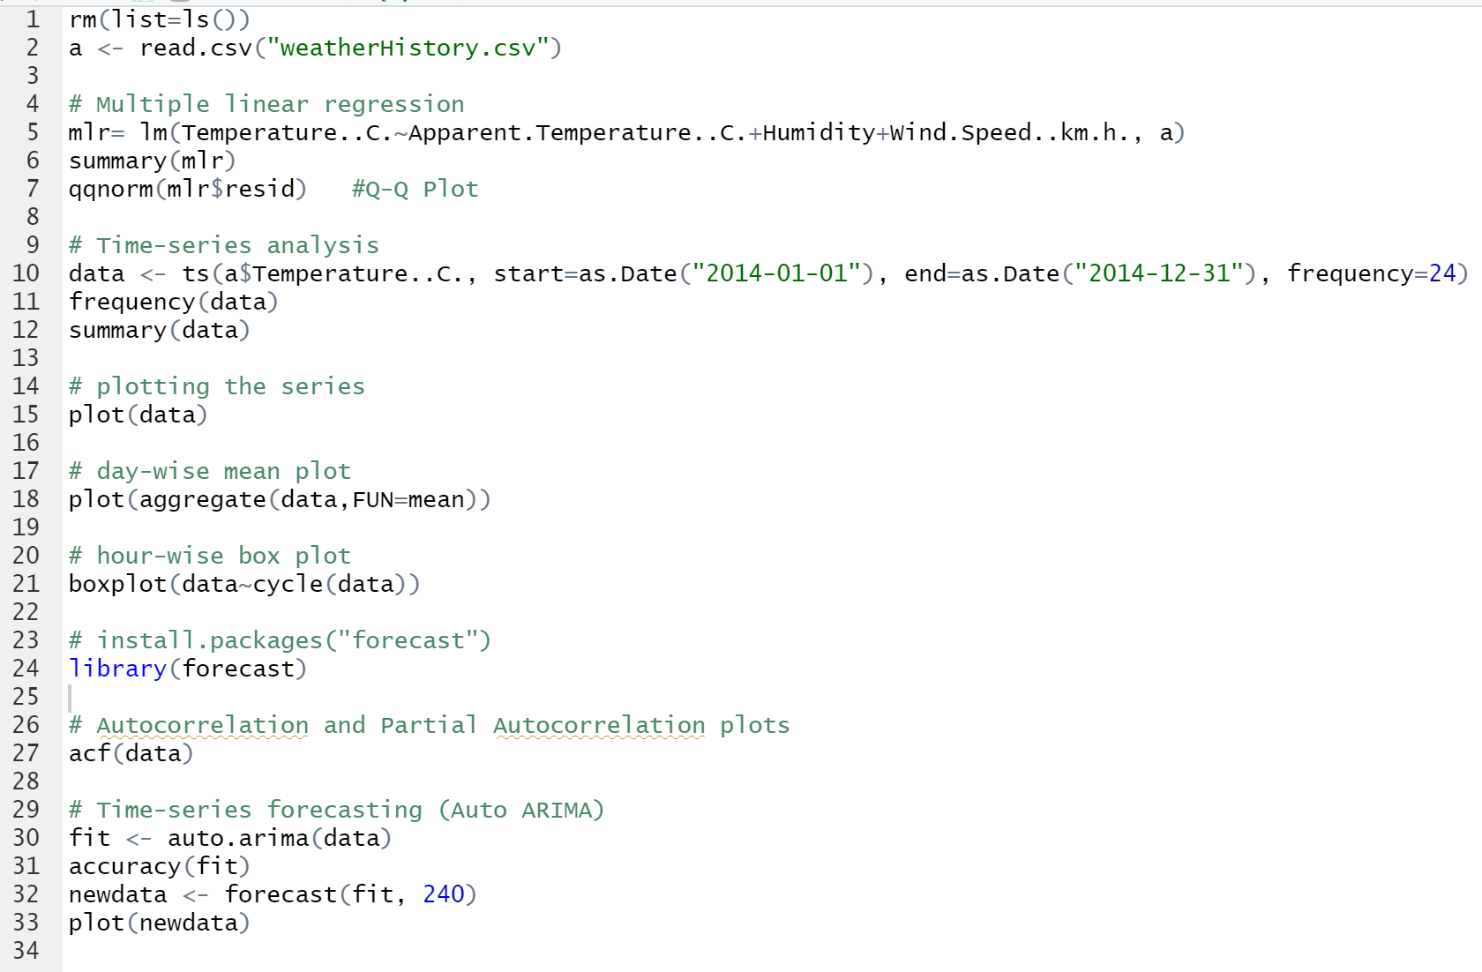

**OUTPUT**

